◆ Platform User Guide — School Principal ◆
For: the school principal — whose scope is their own school alone
The platform learns your school the first time you sign in and fixes it: you do not choose a complex or a stage on every screen, and you never see another school's schedule.
Before you start — four things that concern everyone
1. Open the link — https://ahseyam.github.io/unified-lesson/
2. Switch to English — the EN button, top right
3. Choose your role — one card per role
4. Enter your staff number — you are identified by it, not by your name

• Open the link: It runs on phone, laptop and tablet with nothing to install. Bookmark it — it is your single reference; do not rely on a copy someone sends you, or you will be working from yesterday's data.
• Switch to English: Press it once and the choice is remembered on your device. Arabic is the default for everyone, so nothing changes for your Arabic-speaking colleagues. You may enter your own text in English or Arabic — both are kept as typed.
• Choose your role: Each role sees only what concerns it: its own buttons, screens and reports. You will not see what is not yours, and you cannot press a button that destroys someone else's work.
• Enter your staff number: Names repeat and are spelled in different ways, so the same person appears twice in the reports. If your number is on the roster, your name and subject are filled in for you.
❖ Step by step — with pictures every screenshot is taken from the platform itself, not drawn or imagined
1 Sign in and choose your school once
• Choose the “School principal” card; you are asked for the sector, the complex and the school.
• It is then fixed for you — to change it, sign out and sign in again.
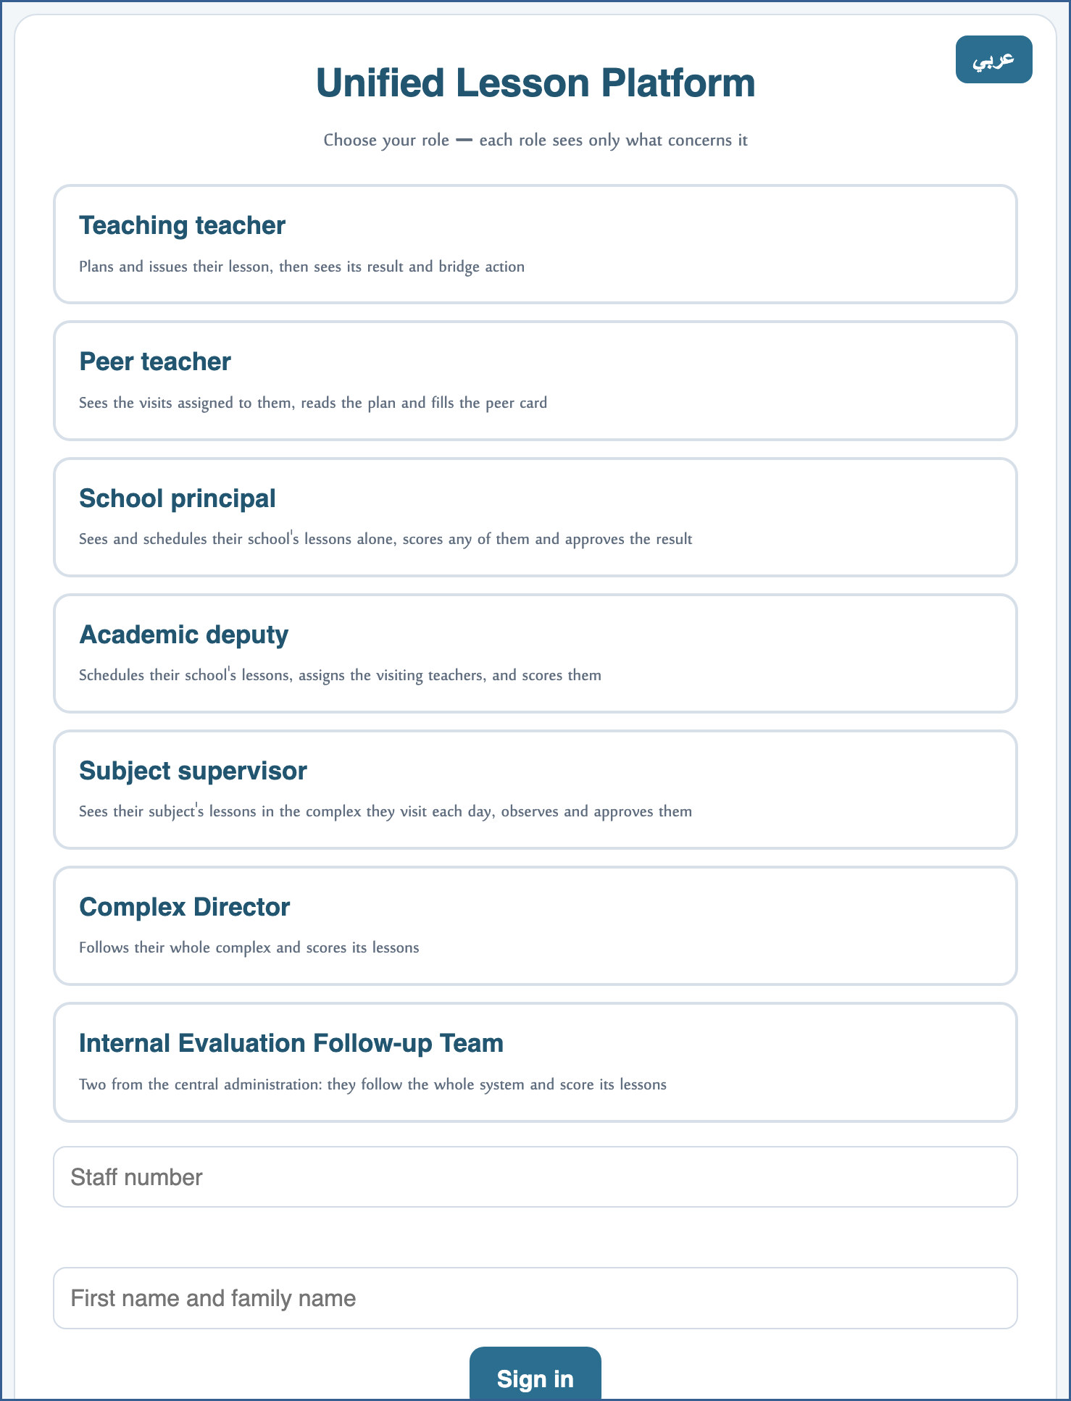
A live screenshot of the platform itself
2 My school's schedule
• You see your school's lessons alone: who has a lesson scheduled, whose plan is complete and whose is not.
• You may type in any cell of your school — completeness is your responsibility.
• Above the schedule, a line says how many names on the roster still have no lesson recorded, and opens their list.
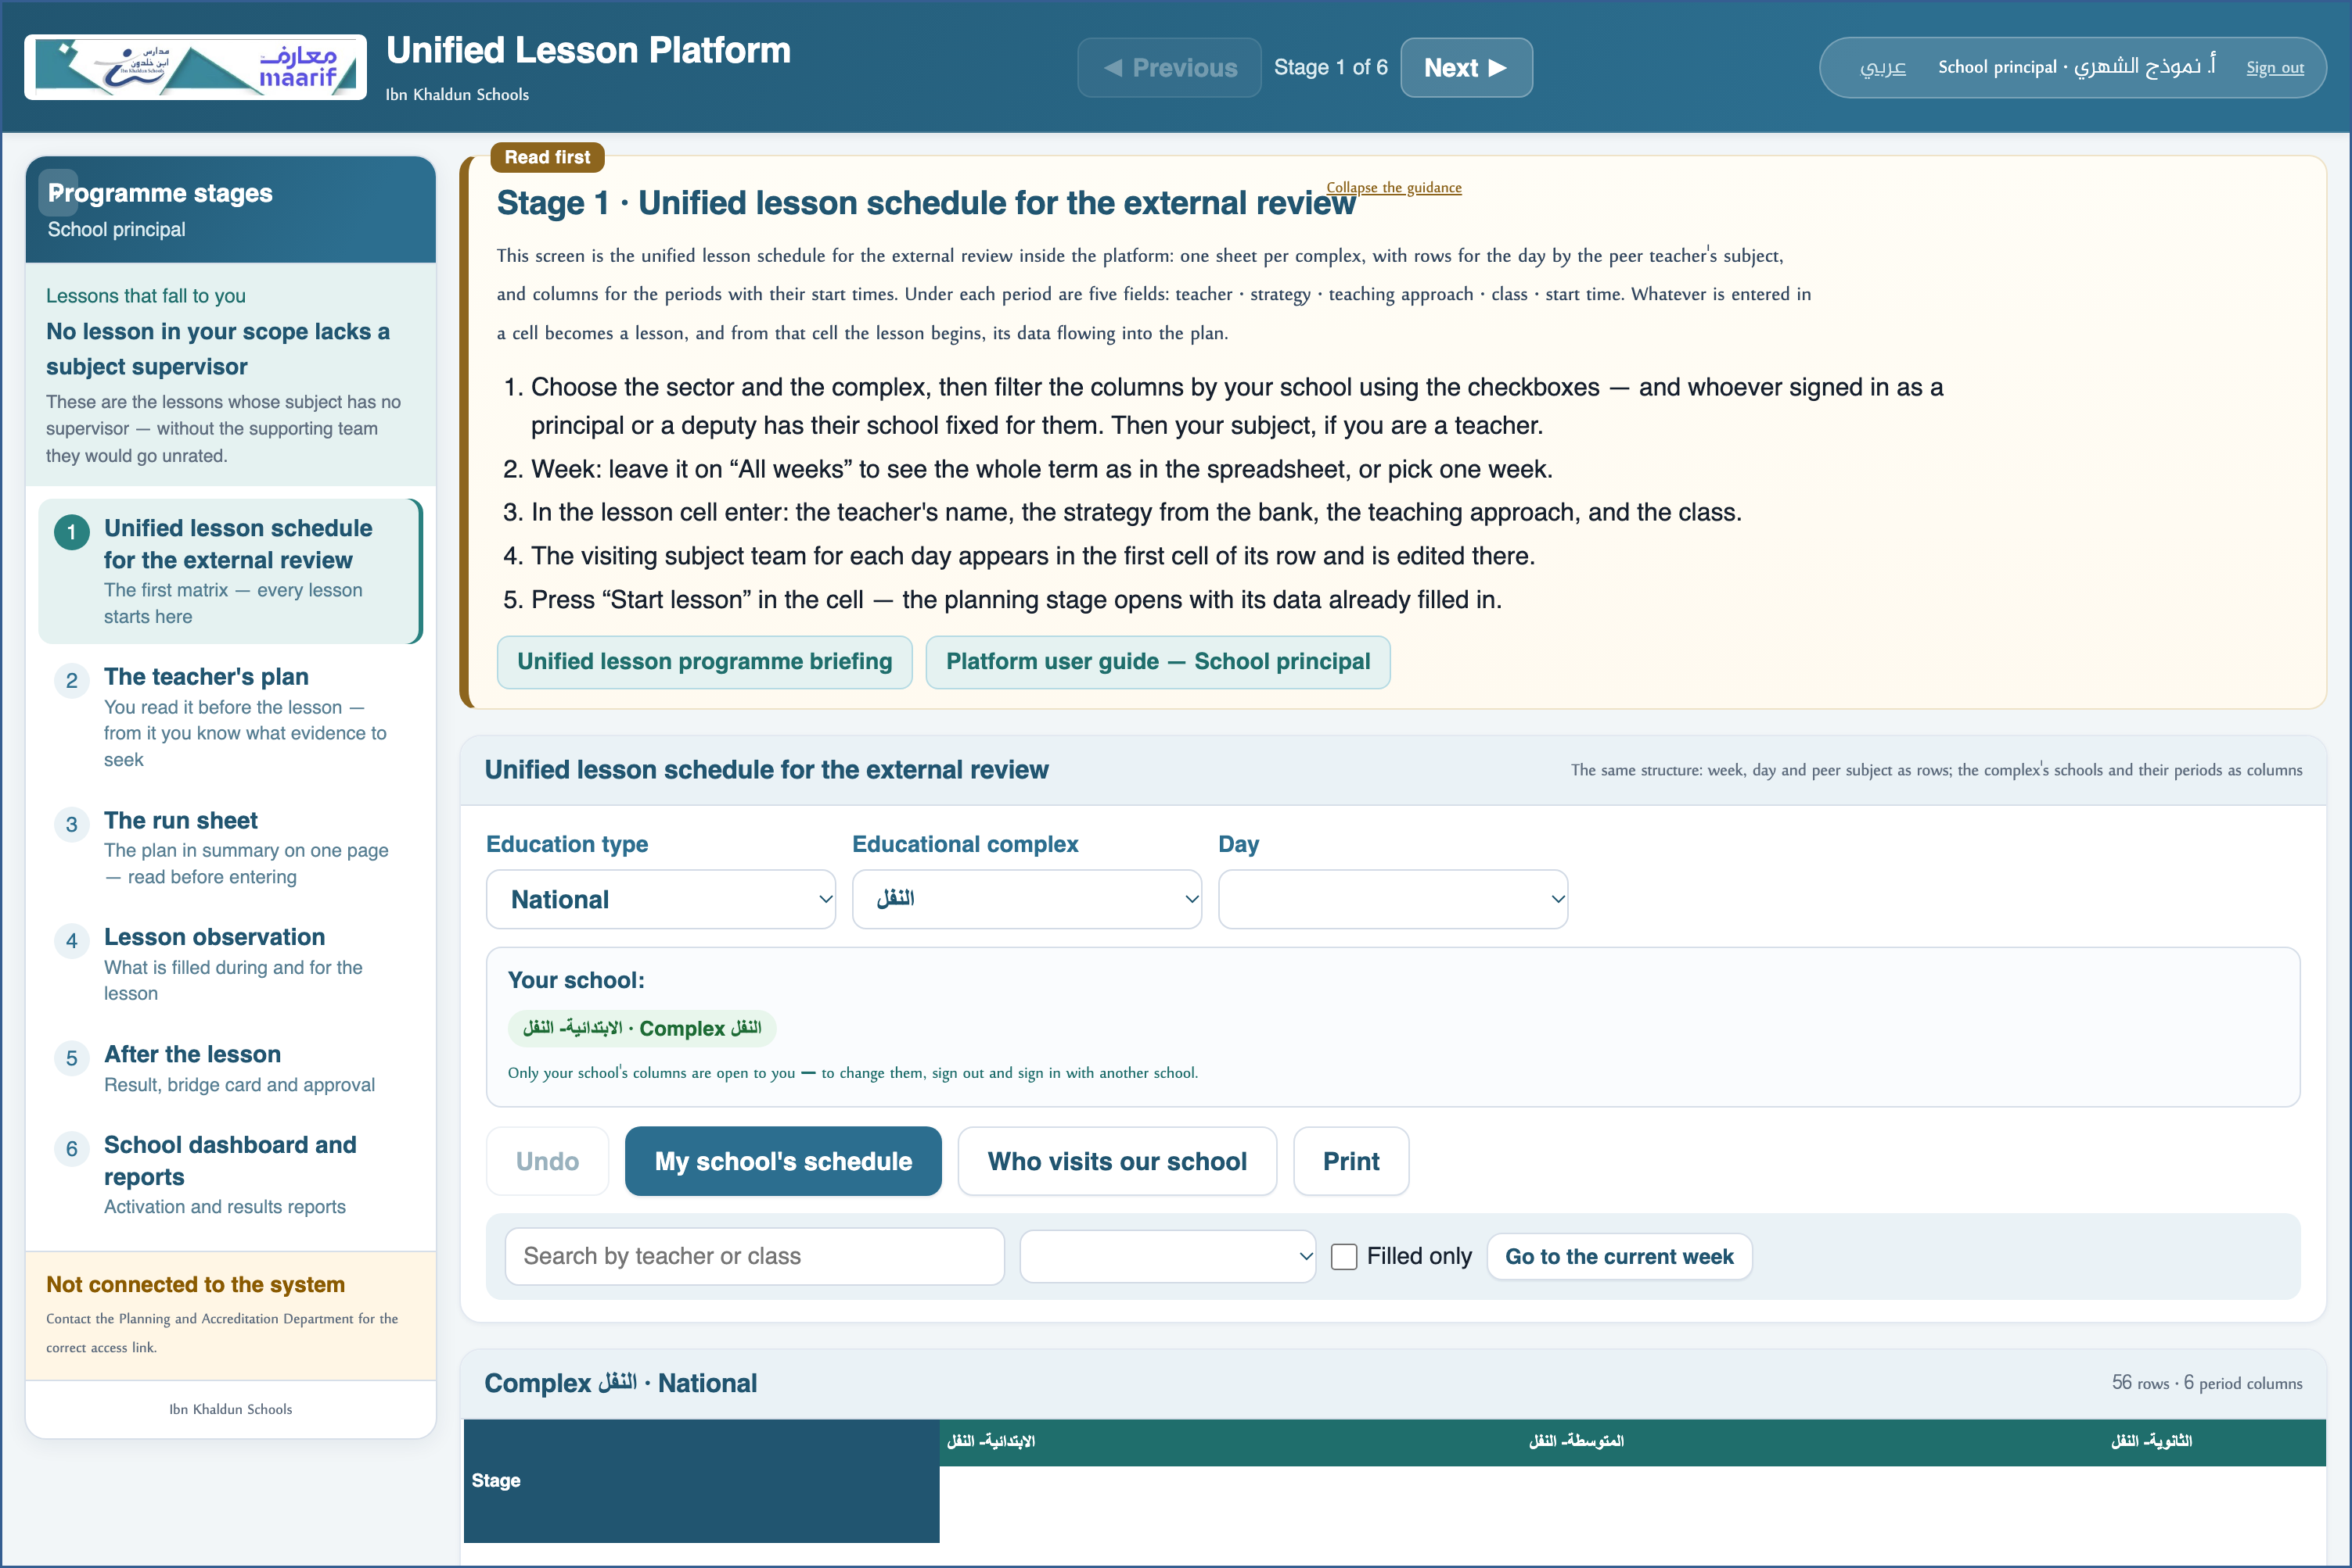
A live screenshot of the platform itself
3 Observe the lesson
• Your capacity on the card is filled from your role — you are not asked for it and it is not changed here.
• Complete the rubric during the lesson: the indicators with their scores, and the evidence with what you saw.
⛔ What you write is attributed to you by name in the reports — write it precisely.

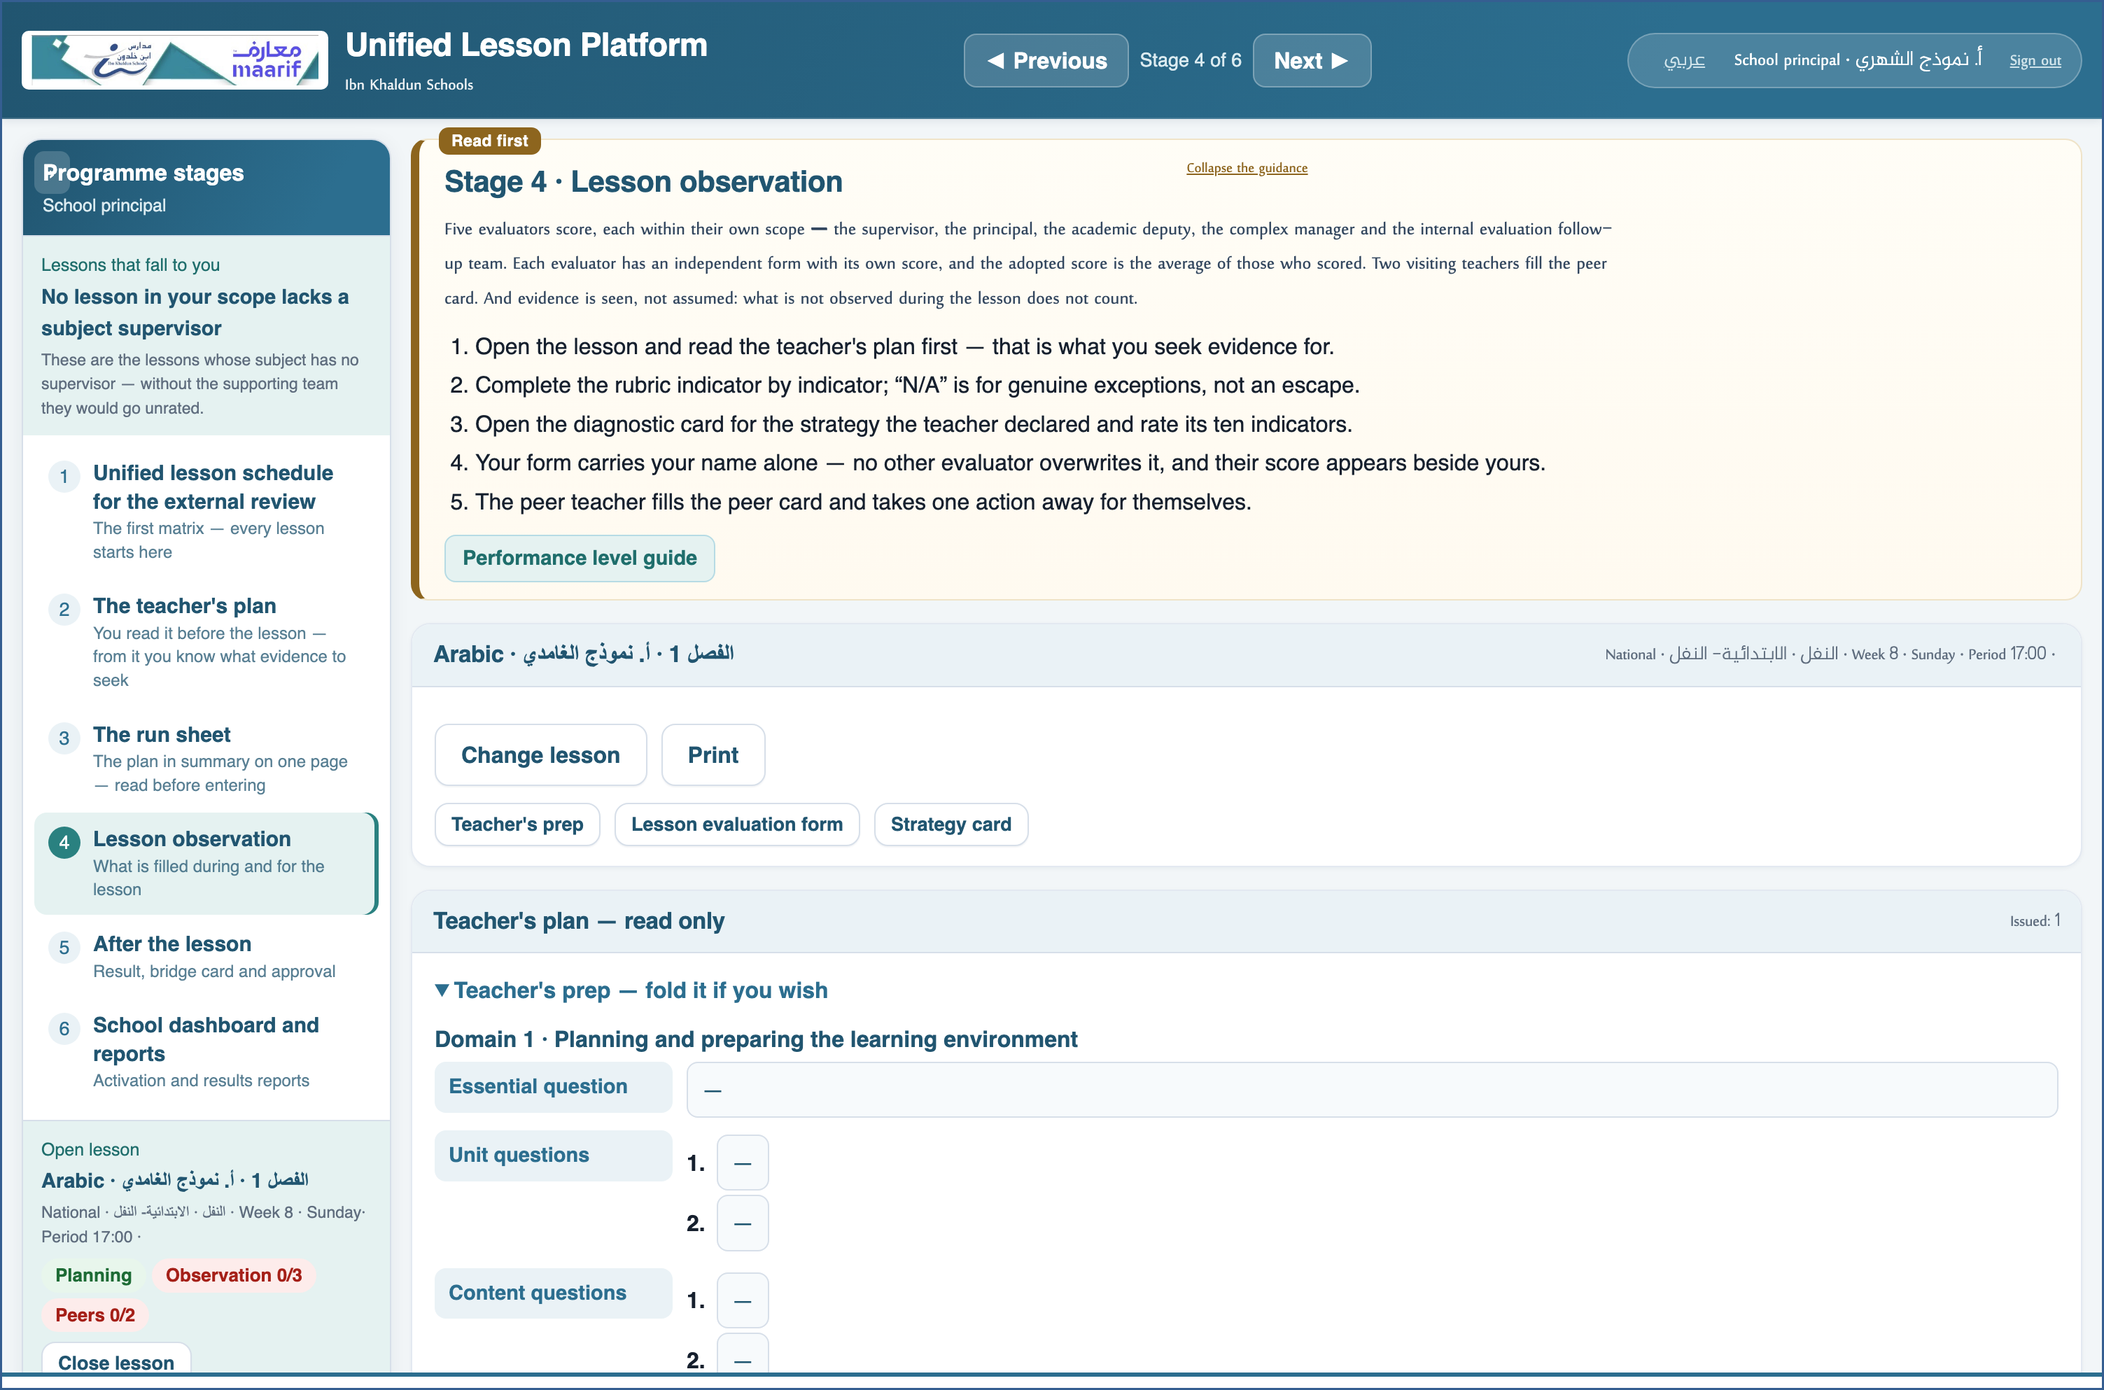
A live screenshot of the platform itself
4 Approve the result and lock the lesson
• Once the observations are complete, the score, its level and the bridge action appear.
• Approval locks the lesson: after it, the schedule, the plan and the observations cannot be changed.
⛔ Do not approve a lesson no one has observed — unlocking requires a confirmation and is recorded in your name.

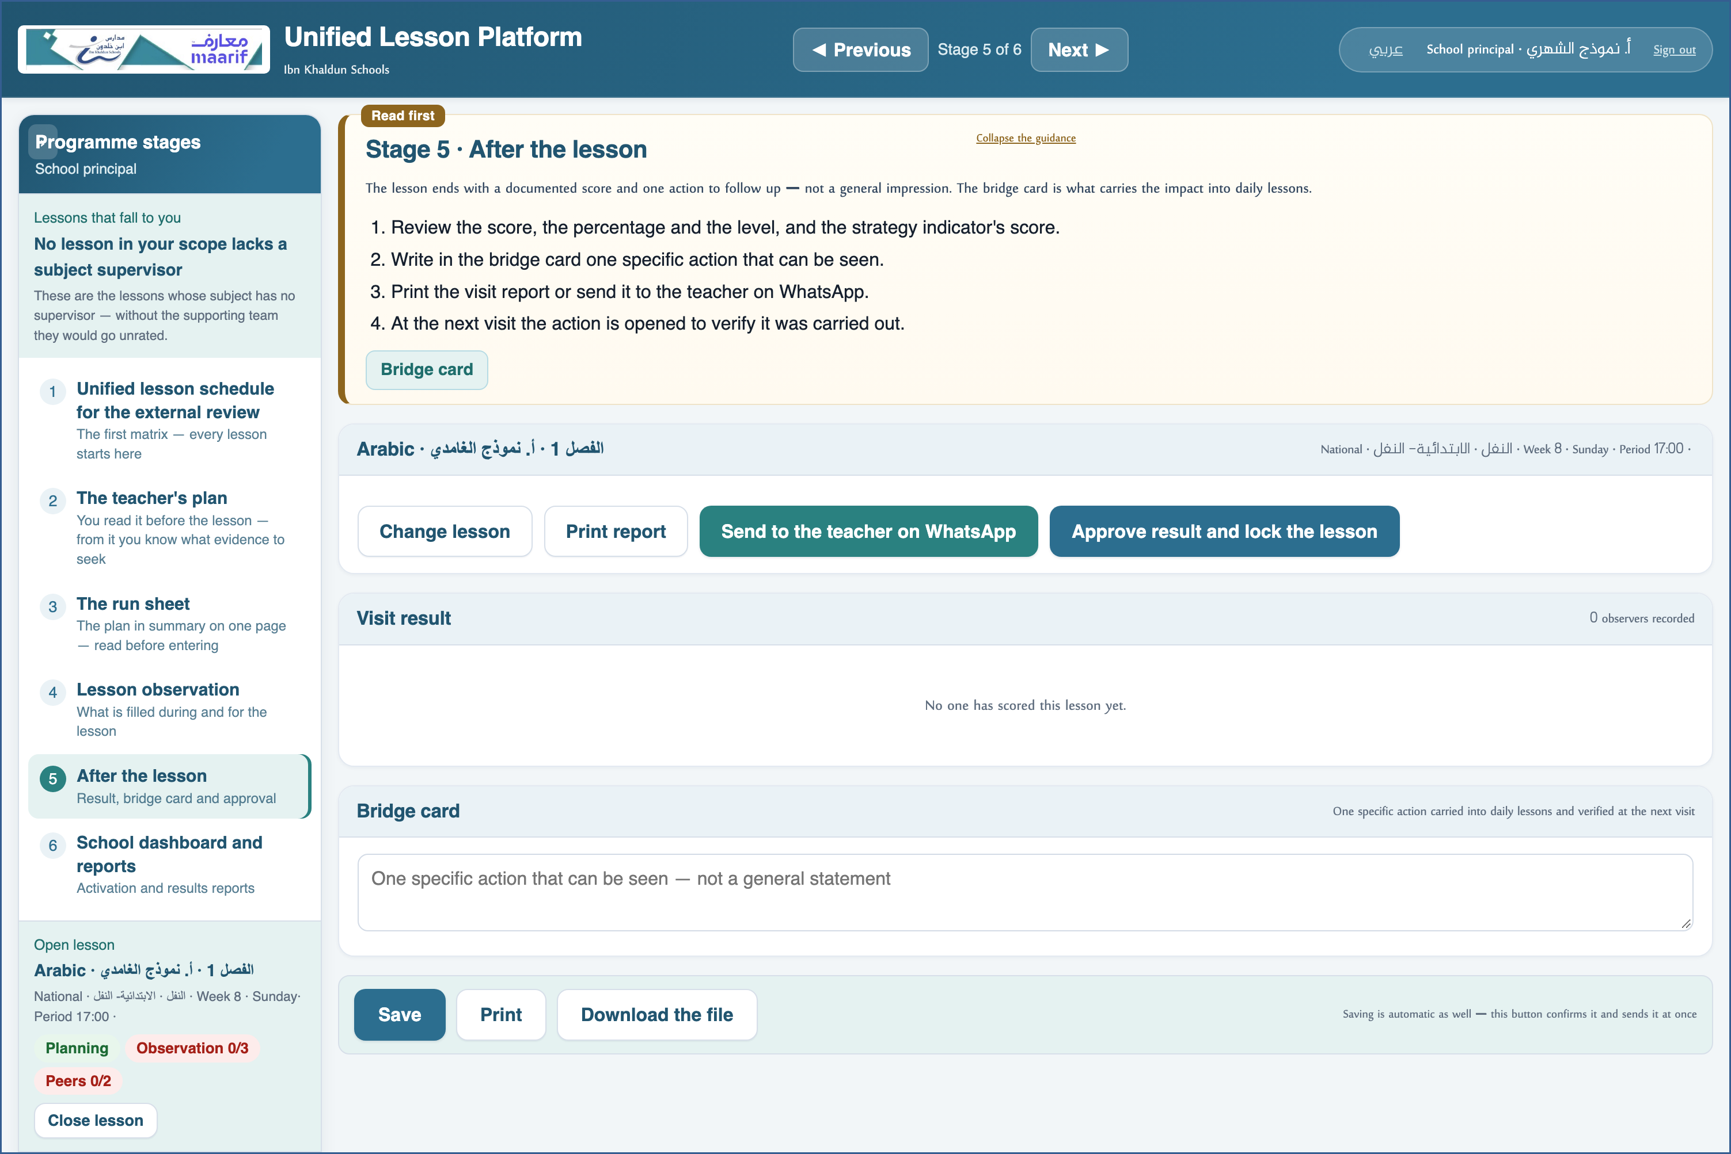
A live screenshot of the platform itself
5 School dashboard and reports
• Activation reports: who planned and who did not, who has been observed and who is waiting.
• Results reports by indicator, by teacher and by stage — exported as CSV for analysis.
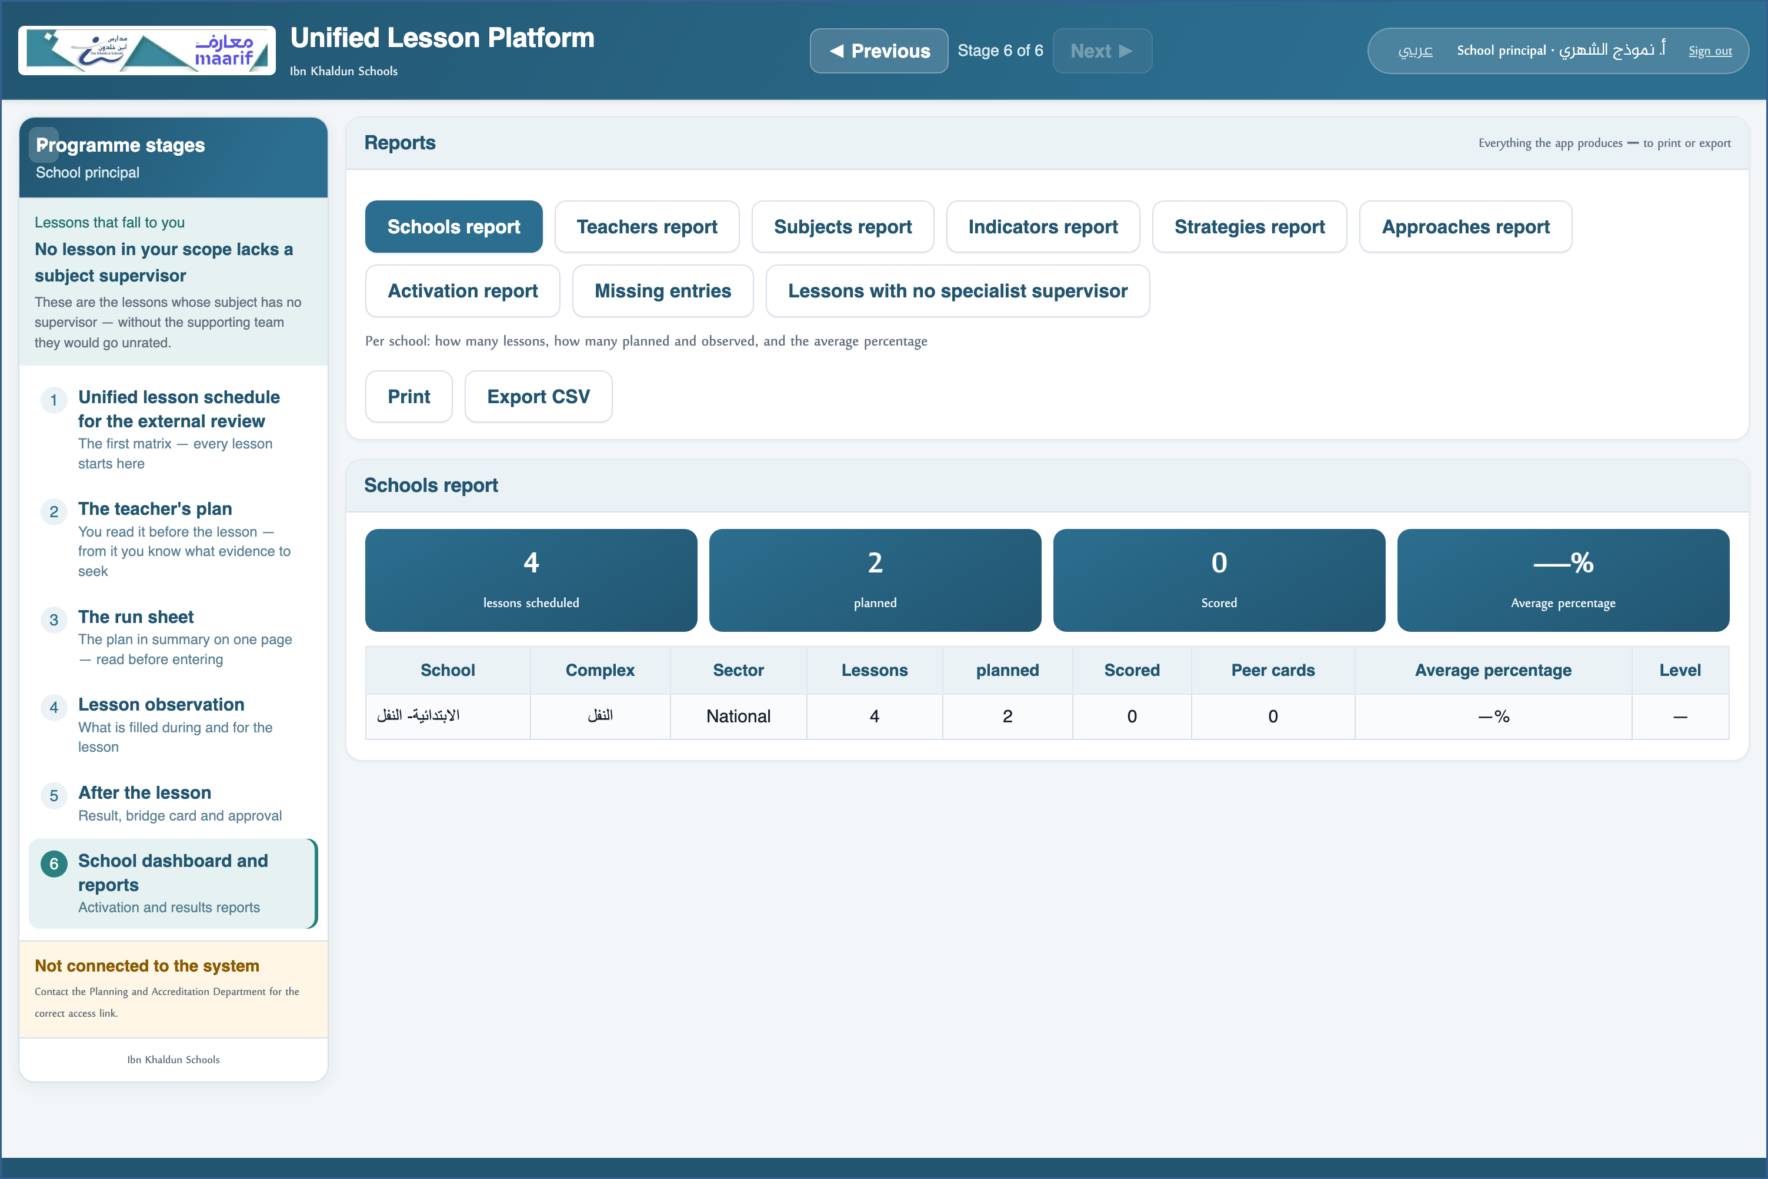
A live screenshot of the platform itself
❖ Where things usually go wrong before you ask — the most common cases
What happens | Why, and what to do
I do not see “Where I visit — supervisor rota” | Because you do not rotate between complexes. That is for the subject supervisor alone.
I do not see “Assign peers” | Assignment belongs to the academic deputy — they are the one who sees it.

❖ Frequently asked
Q: Do I see the complex's other schools?
A: No. Your scope is your school, and that is deliberate, to protect others' data.
Q: I run two schools — how?
A: Sign out and sign in with the other school; what you entered in the first is kept as it was.
Who to contact
If what concerns you does not appear, or something that is not yours does — contact the Planning and School Accreditation Department.
If the page does not open at all — check the link above and your connection.

https://ahseyam.github.io/unified-lesson/
Planning and School Accreditation Department · Ahmed Seyam

